|  |
| --- |
| **CS 590 BD – Big Data Analytics and Applications** |
| **Lab 1 - Assignment** |
| ***Submitted By: Beeravalli Ramakrishna Reddy (16179758)*** |

|  |
| --- |
| Ramakrishna Reddy Beeravalli  6-17-2014 |

***Task 3: ScrumDo***

***Task 3.1 Github***

Creating Account

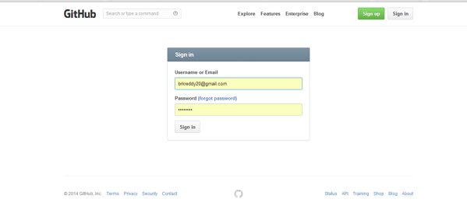

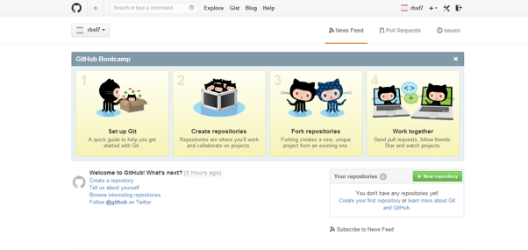

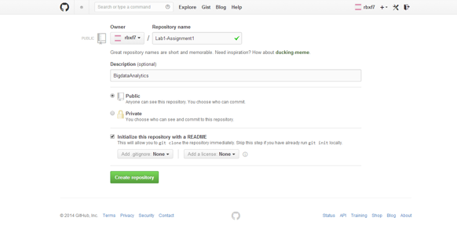

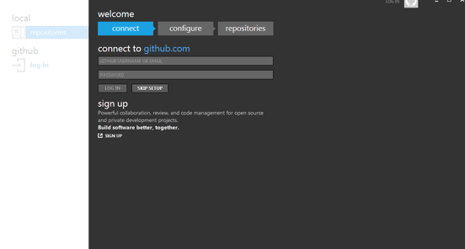

***Task 3.2 To create an account and projects with scrumdo***

ScrumDo is an agile management tool

Step 1

Creating Account

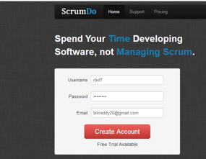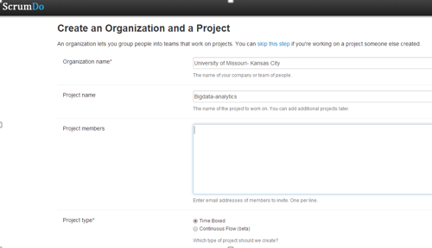

Creating Iteration

